COMP2003HK Computing Group Project (22/AY/AUNS/M) - Group 9

Natural Science Survey System

**Initial Project Plan**

Group Members:

|  |  |  |
| --- | --- | --- |
| Name | Leadership Role | Plymouth Email/ID |
| Tse Chi Kin | Product Owner | chi.k.tse@students.plymouth.ac.uk |
| Lee Tang Tat Ted | Scrum Master | tang.lee@students.plymouth.ac.uk |
| Kwok Wing Hong | Technical Lead | wing.h.kwok@students.plymouth.ac.uk |

GitHub Repository: <https://github.com/hkuspace-pu/project-submission-group-9>

**Project Vision**

Hong Kong Bird Hub (HKBH) is a cross-platform online system which provides instant access to a database of bird observations. Whether you are a scientist, researcher or amateur naturalist, HKBH is a user-friendly application to keep records of species conveniently, safely and securely. It is also fun for the general public to use HKBH to share their bird observations while a love-to-nature message is inspired as everybody participates. Unlike other applications, all information submitted to HKBH is approved before being published to the general public.

**Project Objectives**

* Surveyors can record and submit a record using any device within 5 minutes.
* Moderators can approve an observation submission within 2 minutes.
* Researchers can find the species they need using the search function within 5 seconds.
* The user can register a new account with the system within 2 minutes.
* The user can log in to the system within 5 seconds.

**User Stories**

As a guest user, I wish to:

- Register and login into the system

- Add and discover survey records

- Interact with other users

- Access the service through different devices

As a surveyor, I wish to:

- Add survey records without needing approval from moderators

- Export survey records data

As a moderator, I wish to:

- Approve survey records from guest users

- Manage survey records with full permissions (i.e., add, edit, delete, export)

As an administrator, I wish to:

- Manage survey records with full permissions (i.e., add, edit, delete, export)

- Manage user account status (i.e., banning, changing roles, deleting)

**Use Case Analysis**

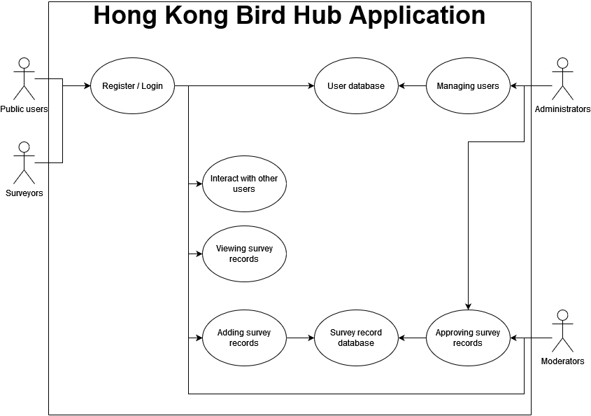

**Initial Sprint Plan**

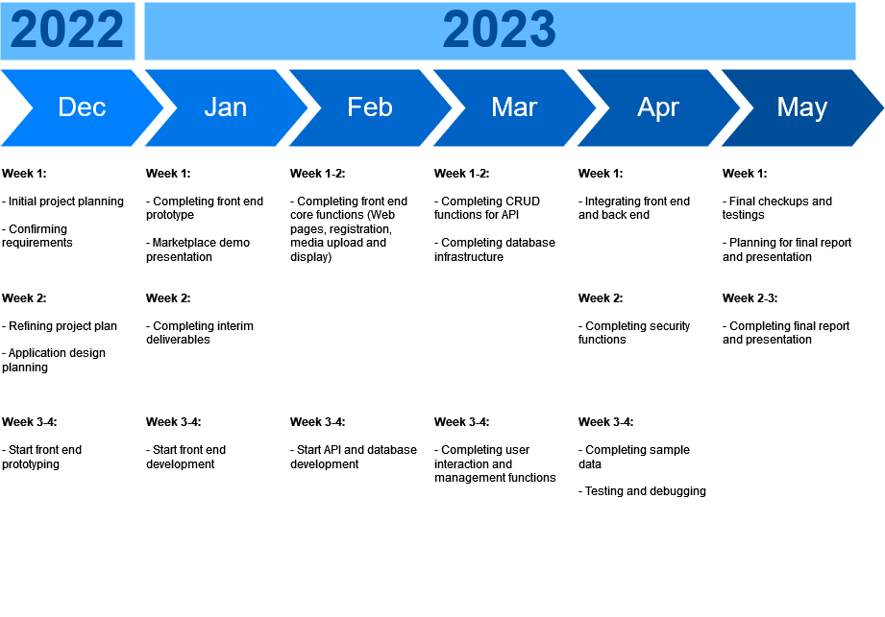

**Risk Management Plan**

Please find below the probability and impact matrix we used for risk estimation.

|  |  |  |  |  |  |
| --- | --- | --- | --- | --- | --- |
| Probability and Impact matrix | | | | | |
| Prob. \ Impact | Trivial | Minor | Moderate | Major | Critical |
| **Rare:** This will probably never happen | Low | Low | Low | Medium | Medium |
| **Unlikely:** Do not expect it to happen | Low | Low | Medium | Medium | Medium |
| **Possible:** It might happen | Low | Medium | Medium | Medium | High |
| **Likely:** It will probably happen | Medium | Medium | Medium | High | High |
| **Very likely:** Will undoubtedly happen | Medium | Medium | High | High | High |

|  |  |
| --- | --- |
| Classification | Description |
| Low | No need to elaborate on a response. This is an accepted risk. |
| Medium | Prepare a quick response. Watch triggers. |
| High | Prepare a detailed response. Watch triggers very closely. |

|  |  |
| --- | --- |
| Response types | Description |
| **Escalate** | Escalate the risk to a higher authority: Client, etc. |
| **Avoid** | Eliminate the cause of risk |
| **Mitigate** | Reduce the probability or impact of risk |
| **Accept** | Contingency plan for risk |
| **Transfer** | Have a third party take on responsibility for risk |

We can estimate the probability of each risk based on past project experience and consider the impact on the project.



**Communication Plan**

|  |  |  |  |  |
| --- | --- | --- | --- | --- |
| Action items | Responsible | Recipient(s) | Method / Channel | When / Frequency |
| Request client feedback | Scrum Master | Dr Ivy Wong | Meeting / Email | At the end of the sprint  At the end of the project |
| Set the status meeting and its agenda | Scrum Master | Team members | Zoom / Whatsapp | Weekly |
| Collaborate with the client on GitHub to define and validate project tasks | Technical Lead | Client’s Team  Team members | GitHub | As needed |
| Report risks and project blockers | Scrum Master | Dr Ivy Wong | Meeting / Email | As needed |
| Functionality testing and review | Product Owner | Team members | Zoom / Whatsapp | At the end of the sprint |
| Sprint Review | Technical Lead | Team members | Zoom / Whatsapp | At the end of the sprint |